Serving Northeastern North Carolina Since 1962 Choanoke Area Development Association of NC, Inc. Post Office Box 530, Rich Square, North Carolina 27869 Telephone: 252.539.4155* Fax: 252.539.2048
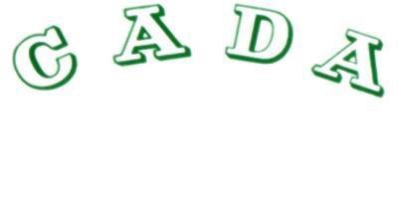

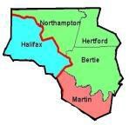

www.nc-cada.org

CADA Continues to Provide Services

In response to the continuing health emergency, all CADA Offices and Head Start Centers will remain closed to the public (walk-ins). For assistance or additional information visit the CADA Website, www.nc-cada.org and click on the Contact Tab to leave us a message or e-mail cada@nc-cada.org . There is an application form on the website. A staff member will respond.
If you do not have access to internet, contact your local CADA Office:
County | Contact Information
Bertie | 252.794.3107 or 252.794.3108
Halifax | 252.537.1111
Hertford | 252.332.2692
Martin | 252.642.7083
Northampton | 252.539.4155
Response time will depend on the number of inquiries/calls received. Your inquiry is important and we will respond. CADA is a Community Action Agency and CARES about our residents and communities.

Sallie P. Surface, Executive Director

